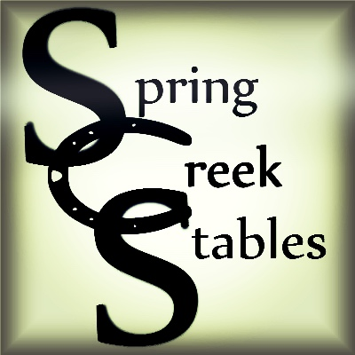
Spring Creek Stables
Horse Camp Registration Form

To register your child print and fill out this registration form along with the release waiver and mail it with your deposit ($200) to:
Spring Creek Stables
25909 Goldfinch Trl
San Antonio, TX 78255

Select a Camp Session: ____ June 11-15 ____ June 25-29 _____ July 16-20

Camper Name:______________________________________ Age:_______
Parent’s Names:__________________________________________________
Address:_______________________________________________________
Email Address:___________________________________________________
Phone:_______________________ _________________________
Emergency Contact:_______________________________________________
Phone:____________________________________
Child’s level of riding experience:_____________________________________
Allergies:______________________________________________________
Please give any other information you think would be important for us to know about your child so we can insure they have a comfortable stay and a good experience______________________________________________________
__________________________________________________________________________________________________________________________________________________________________________________________

We, the parent(s)/guardian(s) will not hold J&L Harms, LLC., dba Spring Creek Stables or Horse Camp Staff responsible for any accident that may happen while your child is at Camp. I grant permission to use images of my child taken at Camp for promotional purposes.

Parent/Guardian Signature and Date:__________________________________

